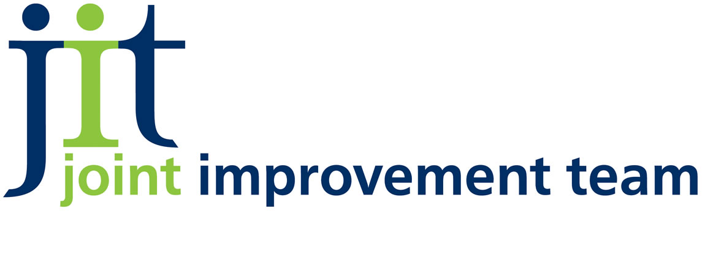

NATIONAL TELECARE DEVELOPMENT PROGRAMME IN SCOTLAND

GLOSSARY OF TERMS AND DEFINITIONS

There is considerable variation in the ways Telecare, Telehealth are defined. The definitions given here are the ones that are used in the National Telecare Development programme in Scotland.

Telecare

There is no universally agreed definition of the term ‘Telecare’; therefore, for the purpose of the national Telecare Development Programme in Scotland, we have adopted the following definition:

“Telecare is the remote or enhanced delivery of care services to people in their own home or in a community setting by means of telecommunications and computerised services. Telecare usually refers to sensors and alerts which provide continuous, automatic and remote monitoring of care needs, emergencies and lifestyle changes, using information and communication technology (ICT) to trigger human responses, or shut down equipment to prevent hazards.”

First, second and third Generation Telecare

Again, there is no standard categorisation of telecare, and for the purpose of the programme in Scotland we have adopted the categories suggested within the guidelines produced by the Welsh Assembly Government in October 2005.

- First generation Telecare refers to equipment and devices found in most Community Alarm Schemes. It refers to user-activated – e.g. push button, pendant or pull cord – alarm calls to a Control centre where a call handler can organise a response of some kind - usually via a neighbour, relative or friend acting as a ’key holder’.

- Second generation Telecare evolved from the introduction into basic Community Alarm services of sensors such as smoke alarms and flood detectors. Second generation Telecare includes sensors which can monitor the home environment, vital signs, physiological measures, and lifestyle. These sensors can collect and transmit information continuously about door opening, bathwater running, the use of electrical appliances, and movement both within and outwith the home. This provides a much more sophisticated and comprehensive support to managing risk and improved quality of life.

- Third generation Telecare arose from improving and increasing availability of broadband, wireless and audio-visual technology. This offers potential for virtual or tele-consultations between the service user and doctor, nurse or support worker, thus reducing the need for home visits or hospital appointments. Furthermore, it leads to increasing opportunities for people - particularly those unable to leave their homes alone - to ‘visit’ libraries, shops and maintain contact with family and friends.

Telecare equipment and devices

There is an increasing range of equipment which can be added to a basic community alarm installation. These are sometimes referred to as ‘Peripherals’. Some need no definition (e.g. smoke alarm), whilst others in regular use are explained below.

Gas detector and Shut-off valve

If this sensor detects dangerous levels of gas, the shut-off valve will terminate the supply and raise an alarm.

Heat, Temperature and Smoke detectors

These sensors will, in addition to raising local audible alarms, also alert the call centre, thus ensuring that an appropriate response is always generated. Carbon Monoxide detectors will detect dangerous levels of carbon monoxide, perhaps from a faulty boiler or gas fire, and will raise an alarm in the home or at the call centre.

Flood detector

A flood detector will raise an alarm if sinks or a bath overflows, or if a washing machine door is opened mid-cycle.

Overflow device

These are specially designed bath or basin plugs, which will automatically release water down the drain if the water level reaches a dangerous level.

Bed or chair occupancy sensor

This uses pressure pads which fit under a mattress or chair and are activated by movement. For example, if someone needs to get up in the middle of the night, it can switch on (and off) a bedside light, a landing or toilet light. It can also be used to alert a call centre if someone does not get up in the morning, or fails to rise from their chair for an unusually long period of time.

Movement detectors

A system of PIRs (Passive Infra Red movement detectors) and door contacts, or pressure pads within door mats, can be set to recognise an individuals ‘normal’ habits and routines, and so create alarms either when the person leaves home for an unusually long period of time, or at an unexpected time; or when there is no activity at all within the home during waking hours. These can reduce risks for people with dementia (for example) as well as enhance security from intruders.

Nocturnal Enuresis alert

These are used in beds. Incontinence is immediately detected, and a carer alerted so that there is no delay in making someone comfortable, and no need for regular manual checking.

Epilepsy alert or sensor

This sensor is placed under a foam mattress or mattress cover and monitors tonic-clonic seizures (the most common form of generalised seizures), so that in the event of a seizure, an immediate alarm call is activated.

Falls detector

This is a device that is worn by someone who is at risk of falling. In the event of a fall, it initiates an alarm call to the call centre, or to a carer. This adds to the feeling of security of the individual concerned, as well as enabling monitoring in falls prevention services.

Medication dispensers

These provide access to tablets of medication over a (e.g.)28 day period, providing audible and visual alerts each time medication is required, and also preventing inadvertent overdosing.

Telehealth Monitors

Telehealth monitors combine with a range of devices to monitor, for example, blood pressure, heart rate, weight and oxygen saturation to provide information to a suitably staffed call centre/’triage station’, and are increasingly being used to assist in the management of Long Term Conditions.

Telehealth

Telehealth is the provision of health services at a distance using a range of digital technologies. Examples of telehealth include video consultations to support diagnosis and management, clinical networks and health professional education.

Telehealthcare

Telehealthcare is the convergence of telecare and telehealth to provide a technology-enabled and integrated approached to the delivery of effective, high-quality health and care services. It can be used to describe a range of care options available remotely by telephone, mobile, broadband and videoconferencing. There is accelerating convergence between telecare and telehealth technologies, with the introduction and expansion of Long Term Conditions monitoring as part of the “telehealthcare” package available in a person’s home, and as part of falls prevention and management. The attached diagram provides examples of the areas of service delivery convergence.

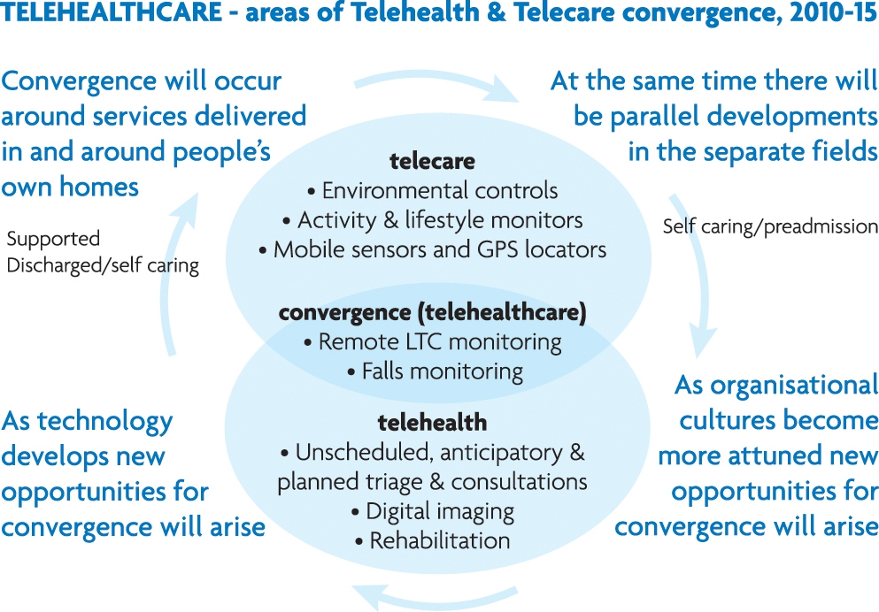

Assistive Technology

Assistive Technology is another collective term for devices for personal use created specifically by applying scientific principles and engineering methods to enhance physical, sensory, and cognitive abilities of people with disabilities to help them function more independently. Thus assistive technology sometimes includes Telecare, but is not limited to that kind of equipment in our use of this term.

Telecare Services

Community Alarms Schemes

Also known as Community Alarm services, they are considered to be a basic introductory form of telecare. They are installations of reactive systems or passive devices which transmit alarm calls. Such schemes or services are now well established in all parts of Scotland. These originated in sheltered housing schemes, but are now more widely available to people in their own homes (sometimes referred to as ‘dispersed units’). A ‘basic package’ of pull chord, button, and/or pendant enables the user to create an alarm at the call or monitoring centre. Latterly, additional peripherals such as heat detectors have been included in the ‘basic package’.

Local areas may have different names for these services, such as ‘MECS’ (Mobile Emergency Care/Call Services), Care line, Care Call’ etc.

Call handling

Community alarm schemes require someone at the end of a phone line who can respond to the alert or alarm call. One or more trained operators (call handlers) provide an immediate, skilled, sensitive response to the person, or to the alarm. Detailed protocols provide a series of instructions the call handler must follow in any eventuality. Usually, with modern equipment, core information (such as address, name of key holders, essential medical information etc.) will appear on screen at the same time as the call comes in. For Telehealth equipment, call handlers either need additional protocols, specialist training, and/or a trained nurse immediately available. This part of the service is referred to as a Call centre, Monitoring centre, or Call Handling service. The latter is our preferred term at present. It creates a clear distinction between the immediate answer of the call or alert, and the assistance that is then provided. We refer to as the latter as the response service.

Response service

Some areas have teams of specially trained personal carers who provide the main response service to most emergency calls. Other areas will have wardens, or similar, who can provide practical help in an emergency, and can appraise a situation (such as a fall, or failure to answer the door) so ensuring that the appropriate emergency service is called. The user is also usually asked to name one or more ‘key holders’ so that, if they are unable to answer their door when in difficulty, someone else can. In several areas of Scotland, access to community alarms service is limited to those who can name at least one key-holder.

Further Information

The Disabled Living Foundation (www.dlf.org.uk ) has published several relevant ‘fact sheets’, notably ‘Choosing a Personal Alarm System’ (2007).

All the major manufacturers publish and update catalogues regularly. These usually include clear definitions of function and application. Technology is improving very quickly, and new applications appear regularly, so these catalogues are an important source of information.

Sponsored booklets and DVDs such as ‘Dementia Care: A technology Guide’ (2005) (available from Tunstall - www.tunstallgroup.com) can also be an invaluable source of information.

The Equipment & Adaptations Branch of the Scottish Government have an excellent page devoted to definitions and shared vocabulary, and can be found at http://www.scotland.gov.uk/Topics/Health/care/EandA/SharedVocabulary.

